# Sir Syed University of Engineering & Technology (SSUET)

# Software Engineering Department

***Course Name: Deep Learning***

***Semester: 6th***

***Batch: 2021F***

***Section: “B”***

**PROJECT REPORT**

***Project Title:*** ***Football Players Analyzer***



***Submitted To:***

***Miss Sanober Soomro***

|  |  |
| --- | --- |
| **Group Members** | **Roll Numbers** |
| Hunain | 2021F-BSE-313 |
| Kashif Rasheed | 2021F-BSE-315 |
| Hamza Ejaz | 2021F-BSE-310 |
| M Owais Nasir | 2021F-BSE-137 |

**TABLE OF CONTENTS**

|  |  |  |
| --- | --- | --- |
| S. No. | TOPICS | PAGE No. |
| 1 | PROBLEM DOMAIN | 3 |
| 2 | PROPOSED TREATMENT | 3 |
| 3 | PLAN OF WORK | 3 |
| 4 | PROJECT SCHEDULING | 4 |
| 5 | SOFTWARE AND HARDWARE SPECIFICATIONS | 4 |
| 6 | BLOCK DIAGRAM | 5 |
| 7 | SYSTEM FLOW DIAGRAM | 5 |
| 8 | USER GUIDE | 6 |

### 1. PROBLEM DOMAIN:

The project focuses on implementing a data analysis system for football player statistics using a dataset of player attributes. The goal is to identify key insights such as the best players in various skills, top earners, and countries with the highest number of players, providing valuable information for team management and scouting.

### 2. **PROPOSED TREATMENT:**

To achieve the project objectives of analyzing football player statistics, the proposed solution involves utilizing data analysis and machine learning techniques. The system will employ libraries like pandas, seaborn, and matplotlib for data exploration and visualization, and a Recurrent Neural Network (RNN) model to predict player potential based on various features. This approach aims to provide an in-depth understanding of player performance and potential, aiding in decision-making for team management.

# 3. PLAN OF WORK:

The project will commence with initial data exploration to understand the dataset, followed by data cleaning and preprocessing. Key components of the project include identifying missing values, calculating and visualizing statistics, and developing an RNN model for predicting player potential. Finally, the results will be visualized using various plots and graphs to present the findings in a comprehensive manner.

## **4. PROJECT SCHEDULING:**

## **5. SOFTWARE AND HARDWARE SPECIFICATION**

* Hardware Requirements:
  + Processor: 1.8Ghz or more
  + Hard Drive: 256 GB or more
  + Memory (RAM): 4GB or more
* Software Requirements:
  + Windows Xp,7,10,11
  + Colab

**6. BLOCK DIAGRAM**

# 7. SYSTEM FLOW DIAGRAM:

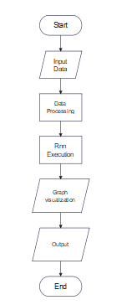

**8. USER GUIDE:**

## The Football Analyzer is a powerful tool designed for comprehensive analysis of football player data. It features data cleaning, machine learning models, and interactive visualizations to provide insights into player performance, potential, and market value. Users can upload datasets, explore metrics, and generate customized reports to support informed decision-making in football management and analysis.

**You can just click on run to execute code:**

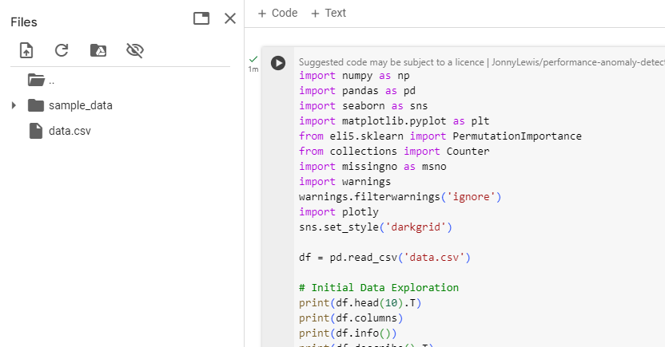

**Output:**

The plot is a **Joint Plot** visualizing the relationship between 'Age' and 'Potential' of players:

1. **Scatter Plot (Center)**:
   * **X-axis**: 'Age' of players.
   * **Y-axis**: 'Potential' of players.
   * **Red Dots**: Each dot represents a player.
2. **Marginal Histograms**:
   * **Top**: Age distribution (most players are around 25 years old).
   * **Right**: Potential distribution (most players have potentials between 60 and 80).

### Key Insights:

* **Age Distribution**: Peaks around age 25.
* **Potential Distribution**: Concentrated between 60 and 80.
* **Age vs. Potential**: Players aged 20-30 have a wide range of potentials, indicating no strict correlation between age and potential.

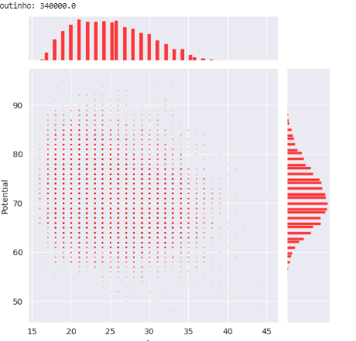

The graph is showing the credibility of a players according to their position. The graph includes heading accuracy, aggression, jumping, agility ,balance ,dribbling , ball control ,positioning and handling.

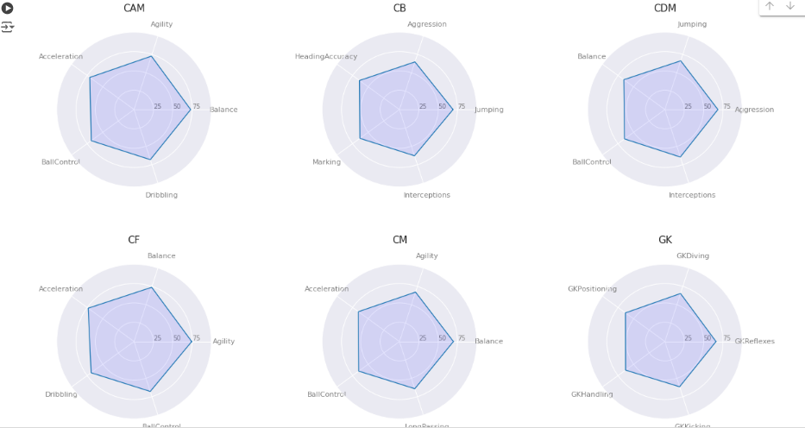

The graph is displaying the relationship between dribbling and ball-control according to their preferred foot it can be left or right depending on player:

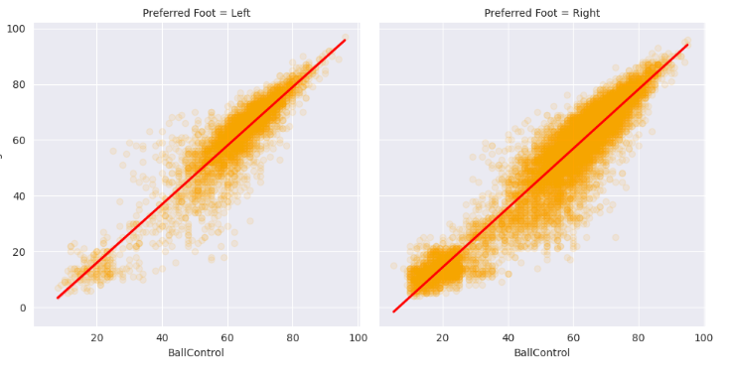

It shows graph between crossing and dribbling:  
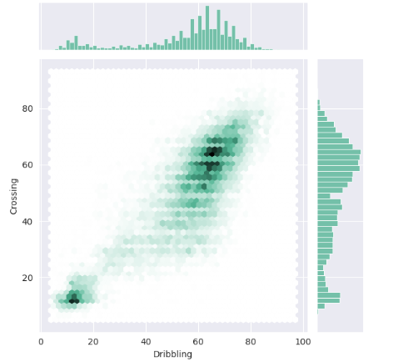

Linear Regression between True Values and Predicted Values

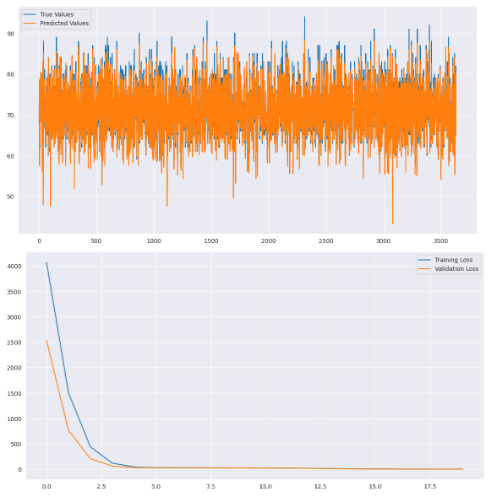

## **REFERENCES:**

Searching on Google, YouTube and We'll provide as you ask